RE: Quarry Lane Grid Stability Project
June 2026
Dear Resident,

I would like to take this opportunity to introduce myself as Statkraft’s Construction Liaison Officer for the Quarry Lane Grid Stability Project. My role is to support local residents and to help address any queries that may arise during the construction period. The project is being delivered on behalf of Statkraft by Elecnor, the appointed construction contractor.
The Quarry Lane project is a grid stability development near the existing Srananagh substation at Ballysumaghan, Co. Sligo. It will use a synchronous compensator to support grid stability and the integration of renewable energy onto Ireland’s electricity system. This notice provides an update on works completed to date and outlines scheduled works due to begin in the area from mid-June.

Road Repairs and Upgrades
- Red line: resurfacing works carried out by the council have now been completed.
- Blue line: the council has addressed the identified problem areas.
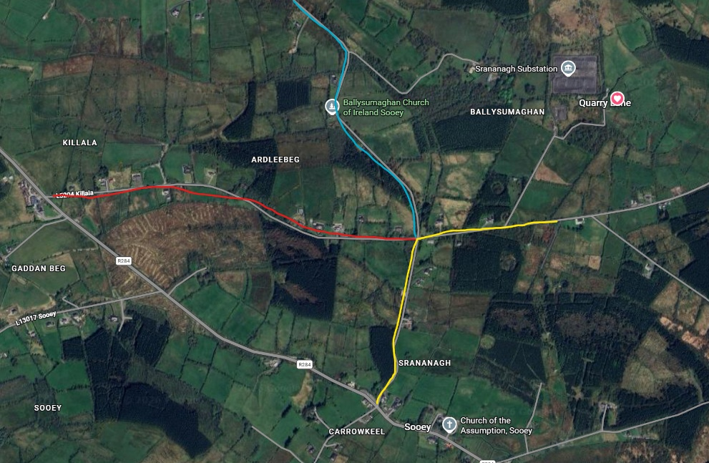
- Yellow line: upgrade works on this road are scheduled for completion in June/July 2026.

General Updates
- A concrete pour is scheduled over the coming weeks the exact date will be posted through updates on the project website.
- Delivery of a crawler crane to the site is expected during the second half of June. The exact date will be confirmed in due course.

Project updates will continue to be published regularly on the project website. You can also use the website to register for email notifications. To access the latest project information updates, please scan the QR code below.

https://projects.statkraft.ie/quarrylane-grid-stability/
On behalf of the developers, I would like to thank residents for their continued patience and understanding throughout the construction period to date.

Yours sincerely,
Suzanne O Leary
Construction Liaison Officer
Email: enquiries@quarrylanegridstability.ie


